Task 1

Task 2

Task 3

Task 4

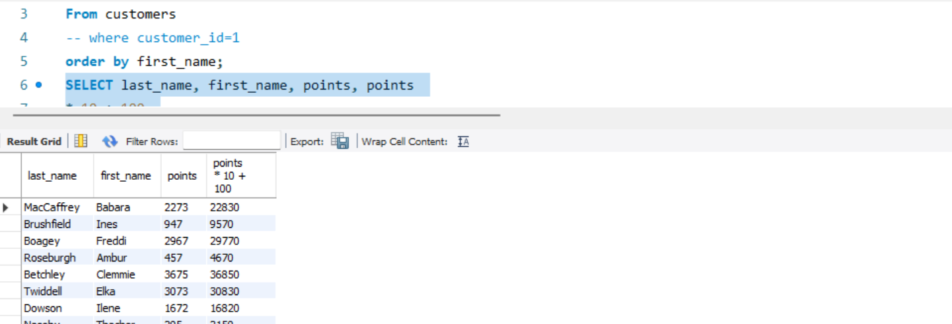

Task5

Task6

task 7

task 8

Task 7

Additional query

